Bridgepoint Parts Catalog

Section XXVIII: Kohler Engine Parts Page 1

PP42-902299

Air Filter - Kohler

Paper Filter Cartridge – Round
Prochem: Legend, Legend SE & Legend XL
7” diameter x 2-1/2”high Bridgepoint: Lancer
Sapphire: 370SS

PP42-902298

Air Filter – Kohler

Foam Pre-cleaner
Prochem: Legend, Legend SE,
Legend GT & Legend XL
Bridgepoint: Lancer & Javelin
White Magic: Pro1600 & Pro 1800
Sapphire: 370SS

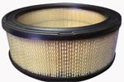


PL24-08303

Air Filter - Kohler

Paper Filter Cartridge – Round

Bridgepoint: Javelin
White Magic: Pro 1600 & Pro 1800
7” diameter x 3”high Prochem: Legend GT

PD47-08301S

Air Filter - Kohler

Paper Filter Cartridge – Round

White Magic: Rebel

7” diameter x 1-3/4”high

PD52-08301

Air Filter – Kohler

Foam Pre-cleaner
White Magic: Rebel



PP42-902277

Oil Filter – Kohler

Prochem: Peak, Peak GTX, Legend, Legend SE, Legend GT
& Legend XL
Bridgepoint: Lancer & Javelin
3” diameter x 2-5/8”high White Magic: Rebel, Pro1600 &
Pro 1800
Sapphire: 370SS

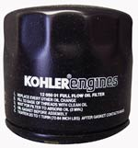
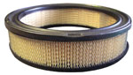

PD25-08301S

Air Filter - Kohler

Filter Cartridge – Primary

Prochem: Peak & Peak GTX
Blueline: Bluewave, Thermalwave II
Thermalwave II HP.
4” diameter x 10-3/4”high

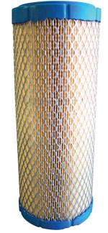

PD52-05002S

Oil Filter – Kohler

Prochem: Peak, Peak GTX, Legend, Legend SE, Legend GT
& Legend XL
Bridgepoint: Lancer & Javelin
3” diameter x 3-3/8”high White Magic: Rebel, Pro1600 &
Pro 1800
Sapphire: 370SS

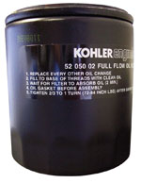

PD25-08304S

Air Filter - Kohler

Filter Cartridge – Secondary

Prochem: Peak & Peak GTX

2-1/4” diameter x 10-3/8”high
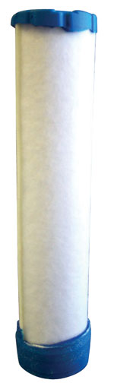

Either size of Kohler oil filter is acceptable for all engines as listed above

Bridgepoint Parts Catalog

Section XXVIII: Kohler Engine Parts Page 2

PFR-RC14YC

Spark Plug RC14YC

Kohler Engines
Prochem: Peak & Peak GTX

PFR-RC12YC

Spark Plug RC12YC

Kohler Engines

Prochem: Legend, Legend GT, Legend SE & Legend XL
Bridgepoint: Lancer & Javelin
White Magic: Rebel, Pro1600 & Pro 1800
Sapphire: 370SS

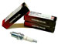
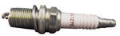

PL24-75598

Voltage Regulator – 25 amp

Kohler Engines

Prochem: Peak, Legend, Legend SE, Legend GT & Legend XL
Bridgepoint: Lancer & Javelin
White Magic: Rebel, Pro1600 &
Pro 1800
Sapphire: 370SS
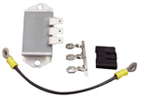

PL24-58409

Module – Spark Advance

S.A.M. – Kohler

Bridgepoint: Lancer & Javelin
White Magic: Pro 1800

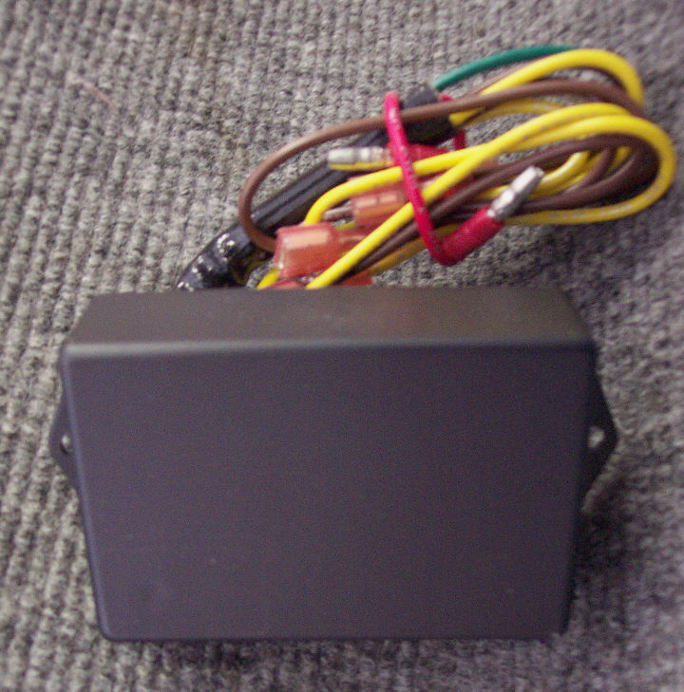

PL24-58411

Module – Ignition

Ignition Coil – Kohler

Used on engines with S.A.M.
Bridgepoint: Lancer & Javelin
White Magic: Pro 1800

On new 22HP engine without the S.A.M., use PL24-58401
On new 25HP engine without the S.A.M., contact service dept.

PL12-085-02

Stator – 25 amp

Kohler Engines
Prochem: Peak, Legend, Legend SE Legend GT & Legend XL
Bridgepoint: Lancer & Javelin
White Magic: Rebel, Pro1600 &
Pro 1800
Sapphire: 370SS

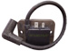

PL24-58401

Module – Ignition

Ignition Coil – Kohler

Used on engines without S.A.M.
Prochem: Legend, Legend SE,
Legend GT & Legend XL
Bridgepoint: Lancer (new 22HP)
White Magic: Rebel & Pro 1600 Sapphire: 370SS

PL24-09801

Starter – Kohler
Prochem: Peak, Peak GTX, Legend, Legend SE, Legend GT
& Legend XL
Bridgepoint: Lancer & Javelin
White Magic: Rebel, Pro1600 & Pro 1800
Sapphire: 370SS
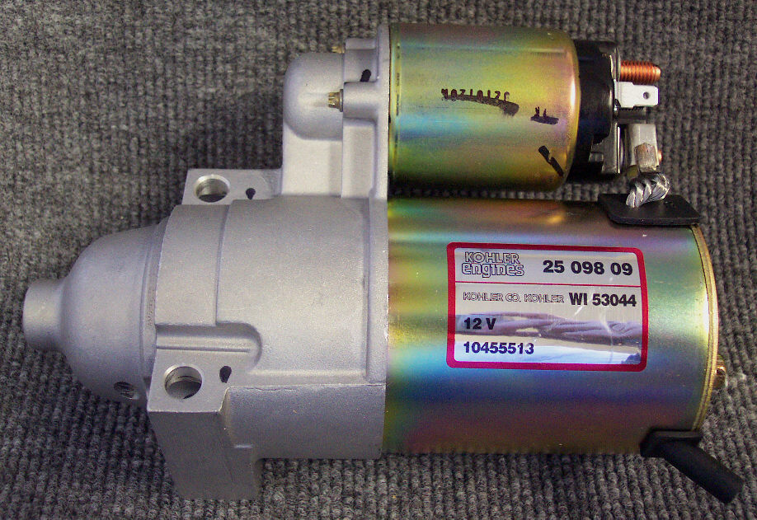
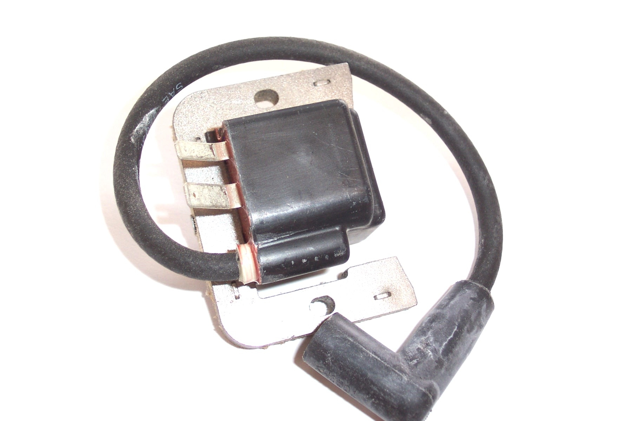

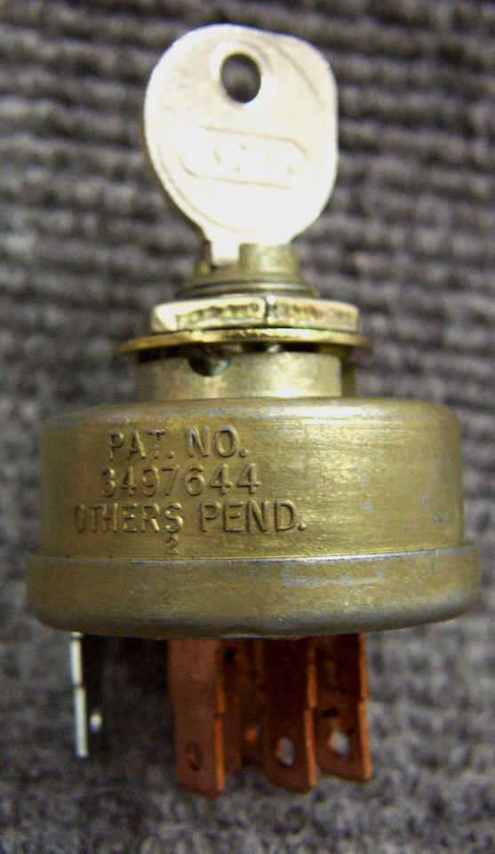

PL25-099-04

Ignition Switch – Kohler

White Magic: Rebel, Pro 1600 & Pro 1800

PHY157-028

Switch – Oil Pressure

